Halloween Edition!
News from the Huddle
October 28, 2014

Congratulations to Amy Collins &
Jonathan Viner on the successful Barristers Big Band concert this past Friday!

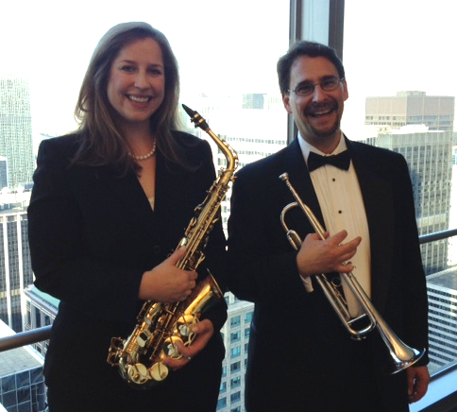

Happy Halloween Nicolaidesians!

Fangs so much Guys and Ghouls for all you BOO to make Nicolaides LLP an eerie-sistable place to be!

Enjoy your week!

Did You Know?

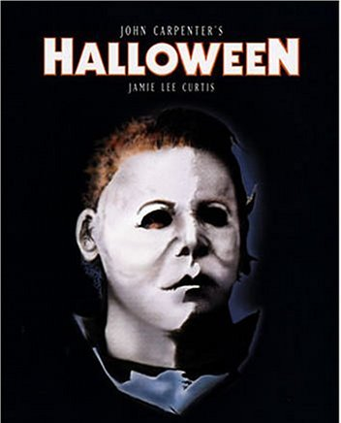

The mask in “Halloween” is actually William Shatner. The film crew bought the cheapest mask they could find and spray painted it white.
News from Nicolaides

Our own Richard Nicolaides was in Tokyo earlier this month meeting with claim reps at AIG's Asian business unit, AIU. While in Japan, Richard also spoke at Mitsui Sumitomo’s international business development conference and enjoyed the local cuisine, including this tasty treat…



BOO!

